Preface

This User Guide explains how to use the system to process reimbursement authorities. It assumes that you are familiar with the basic principles of trade finance relating to reimbursement authorities, and with web browsers.

# About Reimbursement Authorities in Trade Innovation

The system handles reimbursement authorities as a single product called 'Reimbursement'.

Reimbursement is handled in two main stages:

* First the reimbursement authority is recorded on your system
* Then, the claiming bank makes claims against the reimbursement authorisation, which you record on your system and pay, if they are within the terms of the reimbursement authorisation

Reimbursement authorisations can be defined as specific, used to settle claims relating to a single letter of credit only, or as general, in which case they can be used to settle claims relating to different letters of credit issued by the same issuing bank. General reimbursement authorisations can themselves be restricted to claims from a particular bank, a particular country, or up to a maximum amount.

Reimbursement authorities can also be categorised using product types. Your bank can choose what product types, if any, to set up. If your bank has set up product types, you will be able to specify what product type a reimbursement authority belongs to when you create it, and you can use product types to filter which reimbursement authorities you see.

## Claims

You may receive more than one claim against an individual letter of credit involving multiple drafts. Each draft results in a separate claim under the reimbursement authority (although mixed payments count as part of the same claim).

As part of the processing of a reimbursement claim, the system allows you to notify the issuing bank a predefined number of days before the claim is to be settled that their account is to be debited.

## Stopping a Reimbursement Authority

The system includes a facility to allow a reimbursement authority to be stopped at any time between release of the event that created it and expiry. Stopping a reimbursement authority has the effect of preventing payments being made against it.

The system also permits you to reactivate a stopped authority.

## Payment Terms

The system includes facilities for the handling of:

* Sight credits
* Negotiations
* Acceptance credits, where payment is made upon a term draft whose maturity date is determined by acceptance of the draft by a bank
* Deferred credits, where the beneficiary does not need to draw a bill of exchange to receive payment - the issuing bank guarantees that payment will be made at a specified future date if terms and conditions are fulfilled
* Mixed credits, which are a combination of sight and acceptance or deferred credits

When making payments the system allows all relevant charges to be paid with the payment and funds to be paid or received in currencies different from that of the reimbursement authority.

## Financing and Discounting

The system permits you to enter details of a loan to the issuing bank for each part payment claimed (see page 29). You can subsequently record repayment of the loan in part or in full manually. Alternatively, you can set up a loan so that it is repaid automatically as the maturity date is reached. The system also allows acceptance and deferred payments to be discounted and paid early.

If you have Trade Innovation's financing module implemented you can also enter advances against reimbursement authorities. The module permits you to enter loans from within payment events, and also to create financing transactions independent of any existing reimbursement authority. Loans created using the module can have interest in advance or in arrears, or they can be discounted.

For a full description of the financing module's functionality see the Financing User Guide – Trade Innovation.

## Credit Risk Management

If your bank has implemented a credit risk management application, your system will perform on-line credit limit checking as necessary as part of the life-cycle of a transaction. Depending on how your system has been configured, account manager approval for a credit line utilisation may be required always, or only when overline conditions are detected.

See the Common Facilities User Guide – Trade Innovation for more information on credit risk management.

## Reviewing and Authorising Reimbursement Authority Events

By default, the Review step behaves in the usual way for reimbursement authority events, as described in the Common Facilities User Guide – Trade Innovation. Your bank can implement enhanced validation during the Review steps for the following reimbursement authority events:

* Receive Authority
* Amend
* Claim Received
* Continue Claim

This enhanced validation is switched on using the KeyValidation system option, and it requires the reviewer to re-enter key data before the Review step is opened.

You can enter data, then click **OK** to proceed. This input is then matched against the values held on the master record. If it matches, the step proceeds as normal; if not, error messages are produced identifying the discrepancies, and you must correct these before the step can proceed.

Pressing **Reject** returns the event's status to 'Awaiting' at an Input step. Pressing **Cancel** closes the step without affecting the status of the event.

The following table shows the key data fields for each of the four events affected:

|  |  |
| --- | --- |
| Event | Key Data Field to Re-enter |
| Receive Authority | Reference (the issuer's reference for the reimbursement authority)  Amount. |
| Amend | Reference (the issuer's reference for the reimbursement authority) |
| Claim Received and Continue Claim | Reference (the issuer's reference for the reimbursement authority)  Value Date  Claim Amount  Credit party |

## Using Trade Innovation to Process Reimbursement Authorities

The table below list the events covered in this Guide, explaining what each event allows you to do. The table lists the names given to events when the system is delivered. Your bank can change these names once the system is installed. Consequently, the names in your version of Trade Innovation may be different from the ones listed here.

There are two names for each event:

* The full name, which is displayed when you choose a new event
* The short name, which is displayed in the Work in Progress pane of the Master Summary window

This Guide uses the full name of each event, as delivered with the system.

In addition to the events listed in the table, you can also use the functionality described in the Common Facilities User Guide – Trade Innovation when processing transactions in Trade Innovation.

|  |  |  |
| --- | --- | --- |
| Full Name | Short Name | What it Does |
| Adjust | Adjust | Allows you to make changes to any of the information held for reimbursement authorities (see page 39). |
| Amend | Amend | Allows you to make amendments to the basic details of a reimbursement authority (see page 38). |
| Cancel Authority | Cancel | Allows you to cancel a reimbursement authority (see page 43). |
| Claim Received | Claim Recv'd | Allows you to record information from the claiming bank, to enter details of documents, and to pay the claim (see page 17). |
| Continue Claim | Cont Clm | Allows you to process the next stage of a claim begun, but not completed (see page 25). |
| Loan Repayment | Repayment | Allows you to record the repayment of a loan made to the issuing bank (see page 34). |
| Reimbursement | Rec Auth | Allows you to enter full details of a reimbursement authority and advise undertakings, when made, to the claiming bank (see page 7). |

## Using Deal Templates to create Reimbursement Authorities

Trade Innovation permits you to create deals (transactions) from templates and/or, if you have the capability ManageDealTemplates assigned, to add, update and delete deal templates.

You can create a new reimbursement authority from a template at one of three points:

* From within the TI Dashboard. In the New Master pane, the Create from Template button allows you to select the template to use. You must specify the Team, the Branch and the Product
* From within the Master Browser window. In the New Master pane, the Create from Template button allows you to select the template to use. You must specify the Team, the Branch and the Product
* From within a transaction, during the Input step of an event that is creating a new master record. The Create from Template link allows you to select the template to use

See the Common Facilities Guide – Trade Innovation for further details.

# Recording a Reimbursement Authority

Reimbursement authorities are created using a Reimbursement event. They can be created in one of two ways:

* Manually, as described in this chapter
* Automatically, following receipt of a SWIFT MT740 message

Depending on how your system is configured, a reimbursement authority created automatically from a SWIFT message may need to be completed manually. In such a case, the system creates a Reimbursement event for the reimbursement authority at the appropriate step, which you can open from within the Master Summary window in the usual way.

To record a reimbursement authority, in the Masters window, select the Team and Behalf of branch and use the drop-down list in the New Masters pane to select 'Reimbursement', then click **New**. The system creates a Receive Authority event at either a Log step or Input step (see page 7), depending on how the Workflow orchestration controlling the event is configured. See the *Workflow Tailoring User Guide* – Trade Innovation for details.

## Logging a Reimbursement Authority

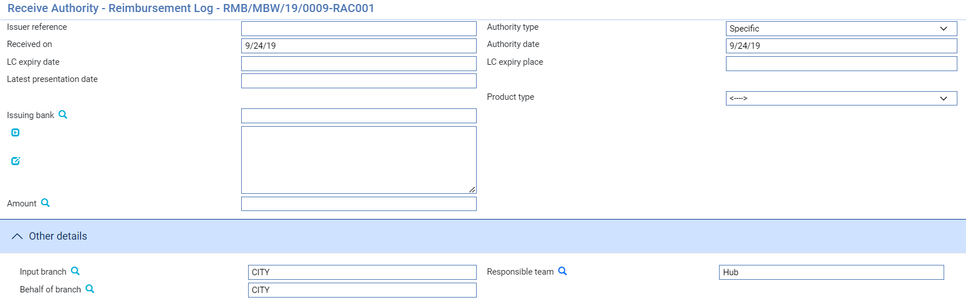

The following table explains what to enter into the fields in this window:

| Field | What to Enter |
| --- | --- |
| Issuer Reference | The issuing bank's reference assigned to the reimbursement authority. For specific authorities, this may also be the reference of the related letter of credit.  The value you enter here is compared to the Sender's Reference for any export letters of credit on your database as well as against the Issuer's Reference for other reimbursement authorities, to ensure that it is unique. If the system finds a duplicate reference, it issues a warning message. |
| Authority Type | Indicate whether the reimbursement authority is specific - that is, valid for a single letter of credit, which is the default - or general. |
| Authority Date | The date the reimbursement authority was created by the issuing bank. This cannot be later that the current processing date. The system uses today's date as the default. |
| Received On | The date you received the reimbursement authority. The system uses today's date as the default. |
| LC Expiry Date | For a specific reimbursement authority the expiry date of the related letter of credit. |
| LC Expiry Place | For a specific reimbursement authority the expiry place of the related letter of credit. |
| Latest Presentation Date | The expiry date of the reimbursement authority which is the latest date on which a reimbursement claim can be received. |
| Product Type | If your bank has set up product types for reimbursement authorities, select the appropriate one from the drop-down list on this field. Depending on the configuration of your system, this field may be mandatory. |
| Issuing Bank | The reimbursement authority’s issuing bank. |
| Authority Amount | The amount of the reimbursement authority and its currency. |
| Input Branch | The input branch for the transaction. The input branch is set from either:   * the accounting branch from the user’s team, or * the transaction branch for user if the user has a default transaction branch or is locked to a specific branch, or * a branch associated with the user where the user can enter transactions for several branches for a team |
| Responsible Team | The team that has overall responsibility for the master e.g. as the contact to resolve any queries or issues regarding the master and associated events. The system defaults the responsible team when creating the transaction as follows:   * Manual – set from team creating the transaction * Gateway – set from the team specified on the incoming message (if present and valid) otherwise to the team to which the transaction is assigned through workflow allocation based on the behalf of branch * SWIFT – set to the team to which the transaction is assigned through workflow allocation based on the behalf of branch   It can be changed, if required, to either the team associated with the primary customer, default team for the product or the user’s current team. |
| Behalf Of Branch | The behalf of branch for the transaction as entered by the user or set from the incoming SWIFT or gateway message. The behalf of branch determines the parameter sets that are to be used to generate charges, documents, postings, etc. during transaction processing. The branch can be changed to any other branch within the same main banking entity that shares the same parameter sets. |

Entering Full Details of the Reimbursement Authority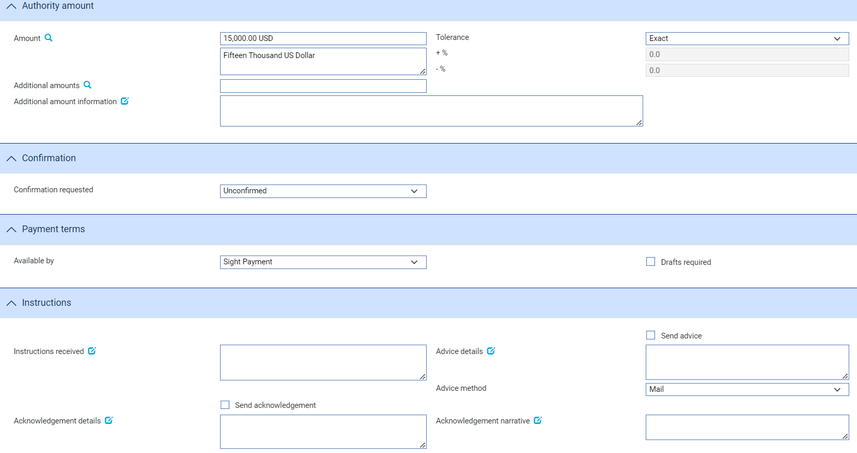

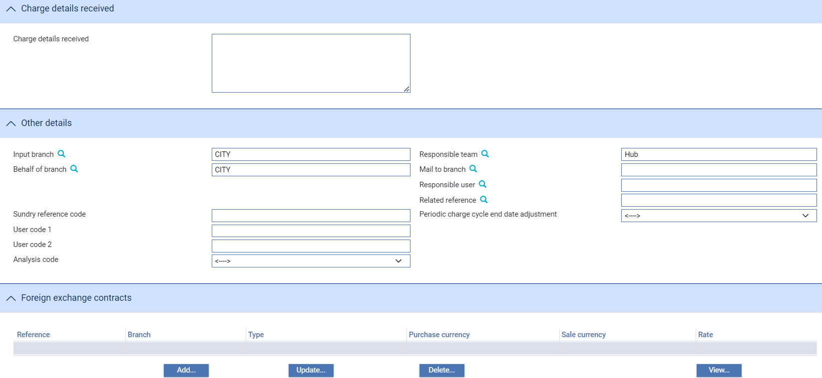

An Input step uses the following panes:

* Reimbursement Authority (see page 8)
* Party Details (see page 9)
* Authority Amount (see page 10)
* Confirmation (see page 11)
* Payment Terms (see page 11)
* Instructions (see page 12)
* Charge Details (see page 12)
* Charge Details Received (see page 13)
* Other Details (see page 13)
* FX Contract (see the Common Facilities User Guide – Trade Innovation)

### The Reimbursement Authority Pane

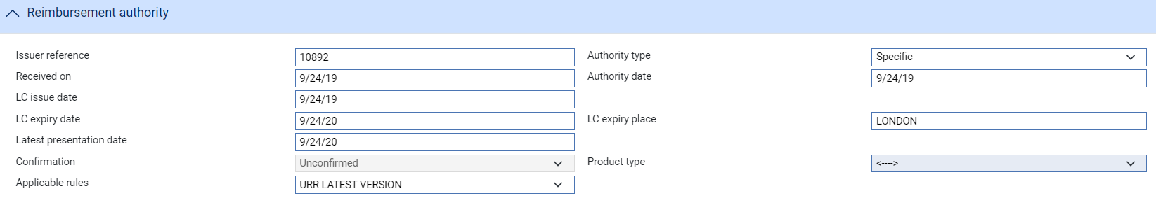

The following table explains what to enter into the fields in the Reimbursement Authority pane:

|  | Field | What to Enter | |
| --- | --- | --- | --- |
|  | Issuer Reference | The issuing bank's reference assigned to the reimbursement authority. For specific authorisations this may also be the reference of the related letter of credit. | |
|  | Authority Type | Indicate whether the reimbursement authority is specific - that is, valid for a single letter of credit, which is the default - or general, in which case it can be used for more than one letter of credit. | |
|  | Received On | The date you received the reimbursement authority. The system uses today's date as the default. | |
|  | Authority Date | The date the reimbursement authority was created by the issuing bank. This cannot be later that the current processing date. The system uses today's date as the default. | |
|  | LC Expiry Date | For a specific reimbursement authority, the expiry date of the related letter of credit. | |
|  | LC Expiry Place | For a specific reimbursement authority, the expiry place of the related letter of credit. | |
|  | Latest Presentation Date | The expiry date of the reimbursement authority, which is the latest date on which a reimbursement claim can be received. The system uses as the default the expiry date of the reimbursement authority.  This date must be entered if you have confirmed the reimbursement authority. | |
|  | Confirmation | The system displays the confirmation status of the reimbursement authority. This reflects what you select in the Confirmation pane. | |
|  | Product Type | If your bank has set up product types for reimbursement authorities, select the appropriate one from the drop-down list on this field. Depending on the configuration of your system, this field may be mandatory. | |
|  | Applicable Rules | Allows you to select additional information to be included in the SWIFT MT740 message generated by the event. Select from the following: | |
|  |  | URR LATEST VERSION | The transaction is subject to the version of ICC Uniform Customs and Practice for Documentary Credits and the version of the Uniform Rules for Bank-to-bank Reimbursements under documentary credits, International Chamber of Commerce, Paris, which are in effect on the date of issue.  This is the default value. |
|  |  | NOTURR | The transaction is not subject to the standards listed above. |

### The Party Details Pane

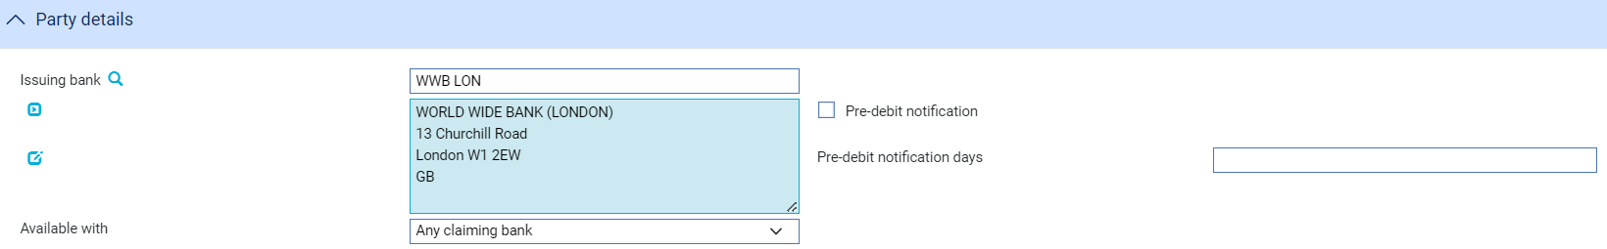

The following table explains what to enter into the fields in the Party Details pane:

|  | Field | What to Enter |
| --- | --- | --- |
|  | Issuing Bank | The reimbursement authority's issuing bank. |
|  | Available With | Select from one of the following to indicate the which bank or banks are authorised to claim reimbursement, and then click Refresh:   * Named Claiming Bank * Any Claiming Bank * Any Claiming Bank in (city) * Any Claiming Bank in (country)   For a confirmed reimbursement authority, you must select 'Named Claiming Bank'.  When you have made your selection, one of the following additional fields may be displayed, depending on what you have selected. |
|  | Available With Bank | For a confirmed reimbursement authority, identify the claiming bank. |
|  | City | If Available With is set to 'Any Claiming Bank in City' identify the city here. |
|  | Country | If Available With is set to 'Any Claiming Bank in Country' identify the city here. |
|  | Named Bank | If Available With is set to 'Named Claiming Bank' identify the bank here. |
|  | Pre-debit Notification/Days | If the issuing bank requires to be notified in advance of a debit to their account, check the Pre-Debit Notification field, enter the number of days' notice they require, up to a maximum of nine days, into the Pre-debit Notification Days field.  The system will use customer and branch details to attempt to establish a default value for this field. |

### The Authority Amount Pane

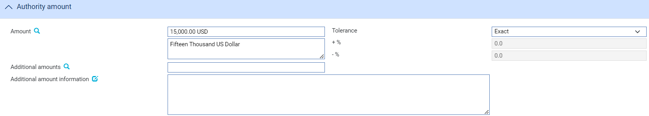

The following table explains what to enter into the fields in the Authority Amount pane:

|  |  |  |
| --- | --- | --- |
| Field | What to Enter | |
| Amount | The amount and currency of the transaction. The system displays the amount and currency in the language of your system beneath these fields. You can edit this text, if necessary. | |
| Tolerance | Specify how the amount is being expressed. Select from one of the following: | |
|  | Exact | If the amount is the exact value of the letter of credit. |
|  | About | If the amount given in the Amount field is within 10% either way of the expected value of the letter of credit. |
|  | Other | If you select this option, use the -% and +% fields to specify as a percentage how much more or less than the final value of the letter of credit the amount entered is allowed to be. |
|  | Not Exceeding/ Up To | If the final value of the letter of credit is expected to be no more than the amount entered, and not less than 95% of the amount entered. |
|  | Min/Max | If you select this option the system displays a + Amount and a - Amount field. Use them to specify as an amount how much more or less than the final value of the transaction the amount entered is allowed to be. |
| Additional Amounts | Any amounts payable to the beneficiary in addition to the principal amount of the transaction. These might include, for example, local freight charges.  If you enter an amount, it is added to the amount of liability under the transaction. If you use a different currency for the amount, then the amount is converted to the currency of the transaction using the current spot rate. | |
| Additional Amount information | A text description of what any additional amounts are for. | |

### The Confirmation Pane



The following table explains what to enter into the fields in the Confirmation pane:

|  |  |  |
| --- | --- | --- |
| Field | What to Enter | |
| Confirmation Requested | Select from one of the of the following values, then click Refresh: | |
|  | Confirmed | If you have been so requested, to indicate that you are making an undertaking by confirming the reimbursement authority. |
|  | Unconfirmed | If you do not want to confirm the reimbursement authority. |
|  | May Add | To indicate that you may confirm the reimbursement authority at a later date. |
| Percentage/Confirmation Amount | If you select 'Confirmed' or 'May Add', specify the amount you are confirming, either as an actual amount or as a percentage.  If you select 'Confirmed', the system uses as default values the full value of the reimbursement authority which is the reimbursement amount plus positive tolerance plus any additional amounts. The amount confirmed can be used to define your liability. | |

### The Payment Terms Pane



The Available By field is used to set the tenor of the payment. See the Common Facilities User Guide – Trade Innovation for instructions. The default value is Sight Payment.

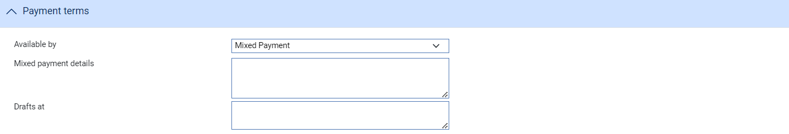

If Available By is set to Mixed Payment then use the Mixed Payment Details field to enter the narrative of details of the mixed payment, and the Drafts At field to enter a narrative defining the payment terms of drafts to be drawn under related letters of credit.

### The Instructions Pane

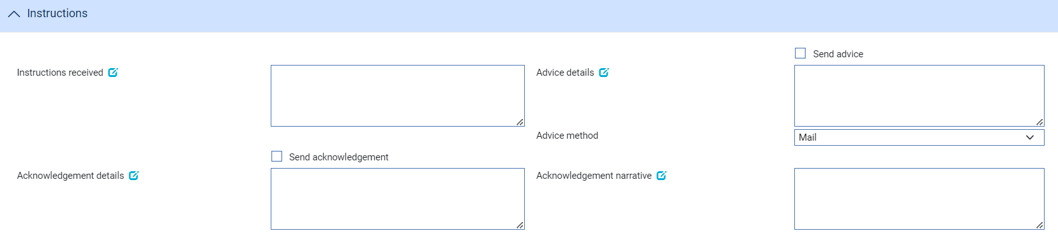

The following table explains what to enter into the fields in the Instructions pane:

|  |  |
| --- | --- |
| Field | What to Enter |
| Instructions Received | Any instructions received from the issuing bank, such as settlement details or additional information on mixed payments, charges and pre-debit notifications. |
| Send Acknowledgement | Check this field if the issuing bank requires the reimbursement authority to be acknowledged. |
| Acknowledgement Detail | Any free format text, for example charge details, to be included on the acknowledgement to the issuing bank. |
| Send Advice | Check this box if the claiming bank requires advice of the reimbursement authority. |
| Advice Details | Any free format text for inclusion on the advice to the claiming bank. This is particularly relevant if the reimbursement authority has been confirmed. |
| Advise Authority | If the reimbursement authority is confirmed, this field is checked, indicating that the claiming bank requires you to issue an advice to them, and an additional field is displayed, allowing you to select the advice method.  Uncheck the field if no advice is required. |
| Advice Method | The method to be used to advise the claiming bank. |
| Acknowledgement Narrative | Information about the acknowledgement of receipt of message. |

### The Charge Details Pane

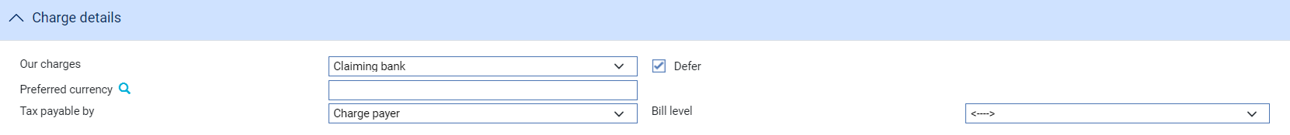

The following table explains what to enter into the fields in the Charge Details pane:

| Field | What to Enter |
| --- | --- |
| Our Charges | Specify which party - the issuing bank (applicant, which is the default) or the claiming bank (beneficiary) - will pay your bank's charges. |
| Defer | Indicate whether your own charges are to be collected now or deferred until payment. Check this box if the charges are to be deferred (the default), otherwise leave it blank. |
| Preferred Currency | The currency in which your charges are to be taken. The system uses as default the currency specified for the product or, if none has been specified, the currency of the reimbursement authority. |
| Tax Payable By | Indicate whether the customer (issuing bank) or charge payer (the party liable for charges, which the system uses as default) is liable for any tax on charges. |
| Bill Level | If billing/invoicing is implemented:   * If billing is to be carried out for all transactions for all products, select 'Customer' * If billing is to be carried out for all transactions for each individual product separately, select 'Product' * If billing is to be carried out for each separate transaction individually, select 'Transaction' |

### The Charge Details Received Pane

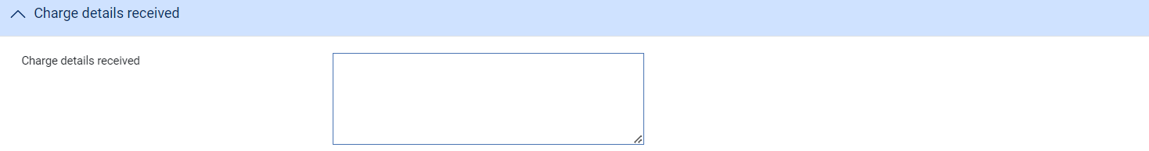

This field is present only if the system option MT740/MT742AutoActionTag71B has been set to Yes, and if the reimbursement authority has been created from an incoming SWIFT message. It displays the content of tag 71B of the SWIFT message. Tag 71B will be flagged as 'Actioned' in the SWIFT In window, and this field allows you to see its content without opening that window.

### The Other Details Pane

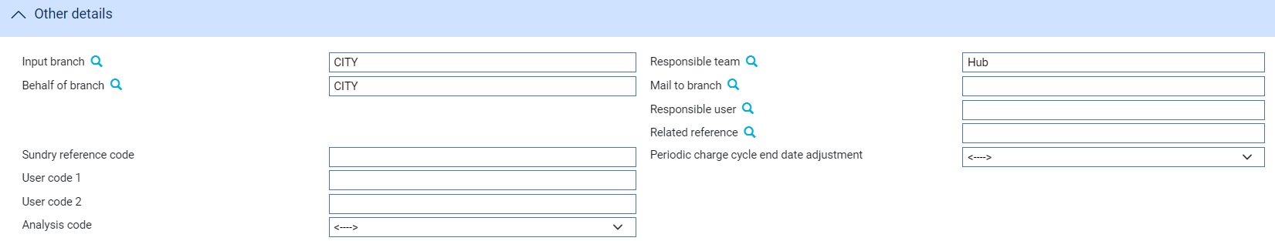

The following table explains what to enter into the fields in the Other Details pane. This pane may also contain fields defined by your bank:

| Field | What to Enter |
| --- | --- |
| Input Branch | The input branch for the transaction. The input branch is set from the either:   * the accounting branch from the user’s team, or * the transaction branch for user if the user has a default transaction branch or is locked to a specific branch, or * a branch associated with the user where the user can enter transactions for several branches for a team |
| Behalf Of Branch | The behalf of branch for the transaction as entered by the user or set from the incoming SWIFT or gateway message. The behalf of branch determines the parameter sets that are to be used to generate charges, documents, postings, etc. during transaction processing. The branch can be changed to any other branch within the same main banking entity that shares the same parameter sets. |
| Sundry Ref Code /User Code 1/ User Code 2 | You may use these fields to enter values for analysis purposes. Your bank will have devised its own system for using these fields. |
| Responsible Team | The team that has overall responsibility for the master e.g. as the contact to resolve any queries or issues regarding the master and associated events. The system defaults the responsible team when creating the transaction as follows:   * Manual – set from team creating the transaction * Gateway – set from the team specified on the incoming message (if present and valid) otherwise to the team to which the transaction is assigned through workflow allocation based on the behalf of branch * SWIFT – set to the team to which the transaction is assigned through workflow allocation based on the behalf of branch   It can be changed, if required, to either the team associated with the primary customer, default team for the product or the user’s current team. |
| Mail To Branch | The mail to branch can be set to any branch within the main banking entity of the behalf of branch. |
| Responsible User | A user that has responsibility for the master e.g. as the contact to resolve any queries or issues regarding the master and associated events. This can be any user assigned to the responsible team. |
| Related Reference | If relevant, the reference of another Trade Innovation transaction master record related to the reimbursement authority. This may be, for example, another reimbursement authority from the same issuer. |

## The Master Summary Window for Reimbursement Authorities

Once you have created a reimbursement authority, the system will display the basic details of that reimbursement authority using the Master Summary window.

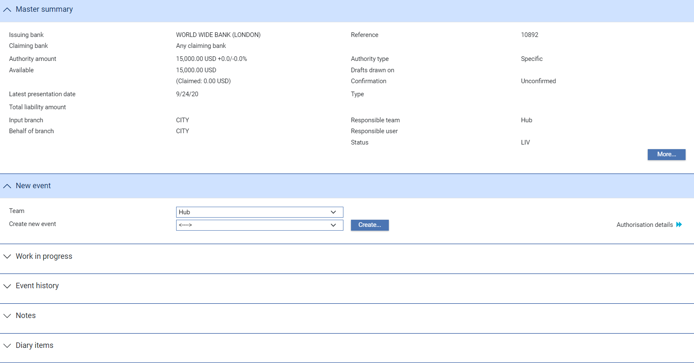

For more information on how the various panes and buttons in this window work see the Common Facilities User Guide – Trade Innovation.

# Claims Received for a Reimbursement Authority

This chapter explains how to use the system to log the receipt of claims against a reimbursement authority and to select the required payment action. This includes continuing claims that are left unpaid pending enquiries.

As claims are received, you can use the system to identify the reimbursement authority they are being made against and then enter details of the claim onto your system. After interpreting the claiming bank's request for payment or acceptance, you can initiate the appropriate payment action and define the payment terms. The Appendix lists claimant's actions for a reimbursement authority.

Two events are used to process claims:

* The Claim Received event (see page 17), which allows you to record information for a claim made by the claiming bank. You can use a Claim Received event to pay the claim, or you can complete the event without making payment while awaiting a response from the issuing bank. A Claim Received event can also be created by an incoming SWIFT MT742 message (and information mapped automatically from that message to the Account With Bank and Other Beneficiary Bank fields for that particular claim, if the system option SWIFTMapInwardMT742 is set on)
* The Continue Claim event (see page 25), which allows you to complete a claim initiated by a Claim Received event and left pending, awaiting the issuing bank's approval. Continue Claim events are also generated by the system as diary events to complete claims when their payment value date is reached

Both payment events permit you to send notification of the impending debit to the issuing bank.

A reimbursement authority may have more than one Claim Received event, and each Claim Received event may have a history of several Continue Claim events associated with it. However, only one Continue Claim event can be in progress for each claim at any one time.

You cannot process a payment event against a reimbursement authorisation that has been stopped. You can, however, reactivate a stopped reimbursement authorisation (see page 38) to allow payment.

## Payment Actions

Payment actions indicate that your bank is paying or will pay the claim in the future:

* Pay
* Pay with Financing
* Pay at Maturity
* Accept
* Adjust Maturity (available only during Continue Claim events and if your system is configured to allow it)

A second type of action involves refusal:

* Reject
* Reject and Claim Refund

The following action leaves the claim outstanding:

* Request Approval from Issuing Bank

The system is delivered with a standard set of ‘Presenter’s actions’ and ‘Payment actions’ which will typically cover the required processing for claims and documentary presentations. However, depending on your bank’s internal processes and requirements, it may be necessary to create additional Presenter’s and Payment actions that are more appropriate to your workflow.

Where this is required, your bank can use System Tailoring to define its own Parameter set based Presenter's actions and Payment actions for Reimbursement authorities and additionally, create Claiming bank’s actions as required. A code and description can be entered for each of these actions together with the associated underlying payment ‘behaviour’ type, such as *General request, Pay, Reject, or Pay at maturity* which then determines the subsequent processing of the payment when the action is selected.

See the *System Tailoring Guide* – Trade Innovation for instructions on defining additional payment actions.

## Payment at Maturity

For claims whose payment action was 'Pay at Maturity' or 'Accept' the system creates a Continue Claim event in the diary to handle the payment at the time of maturity. When the scheduled date of a Continue Claim event is reached the system processes the event during overnight processing. The schedule date is arrived at by applying any pre-debit notification period to the maturity date. If the issuing bank does not require pre-debit notification, the system uses the SWIFT advance days setting for the currency of the payment instead.

You can open a Continue Claim event prior to payment value date and use it to:

* Discount a previously accepted claim prior to payment value date
* Allow financing to be entered for the issuing bank prior to payment value date
* Allow a previously deferred payment to be settled early with or without discounting or financing

When you open a Continue Claim event for a maturity payment or accepted payment the system displays the claim status as 'Pay at Maturity' or 'Accept' respectively.

## Claims Received

To enter details of a claim received, in the Master Summary window select 'Claim Received' from the Create New Event drop-down list and click **Create**. The system opens the event at either a Log step or Input step (see page 18), depending on how the Workflow orchestration controlling the event is configured. See the *Workflow Tailoring User Guide* – Trade Innovation for details.

### Logging a Claim Received

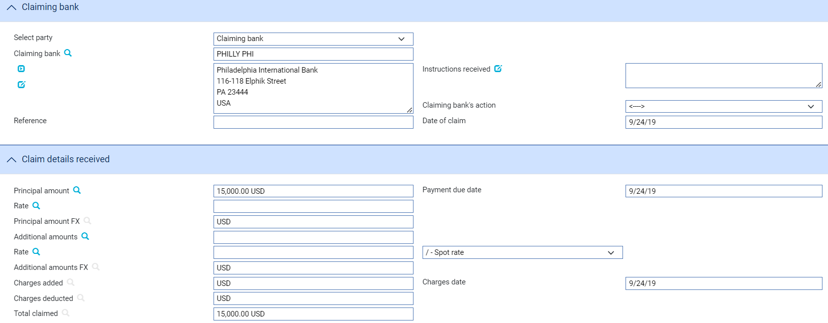

The table below explains what to enter into the fields displayed at a Log step:

| Field | What to Enter |
| --- | --- |
| Select Party | Select the party from whom you received the claim. |
| Claiming Bank | The claiming bank. |
| Reference | The claiming bank's reference for the claim. |
| Principal Amount | The amount being claimed. By default, the system displays the available amount of the reimbursement authority (less outstanding claims) here. |
| Date of Claim | The date the claiming bank issued the claim. |
| Claiming Bank's Action | Choose one of the following values from the drop-down list to indicate what action the claiming bank has taken with regard to the claim:   * Request Payment * Request Acceptance * Sender has Debited our Account * Other |

### Entering Full Details of a Claim

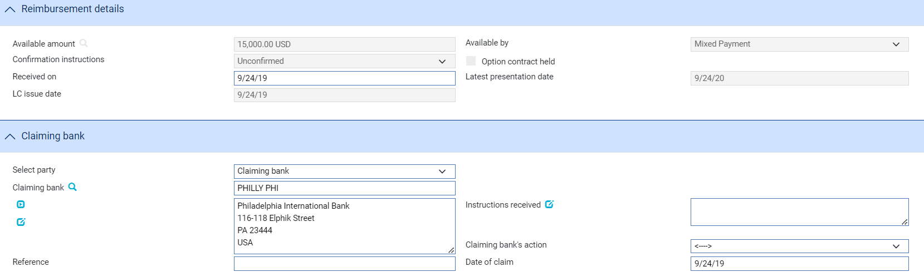

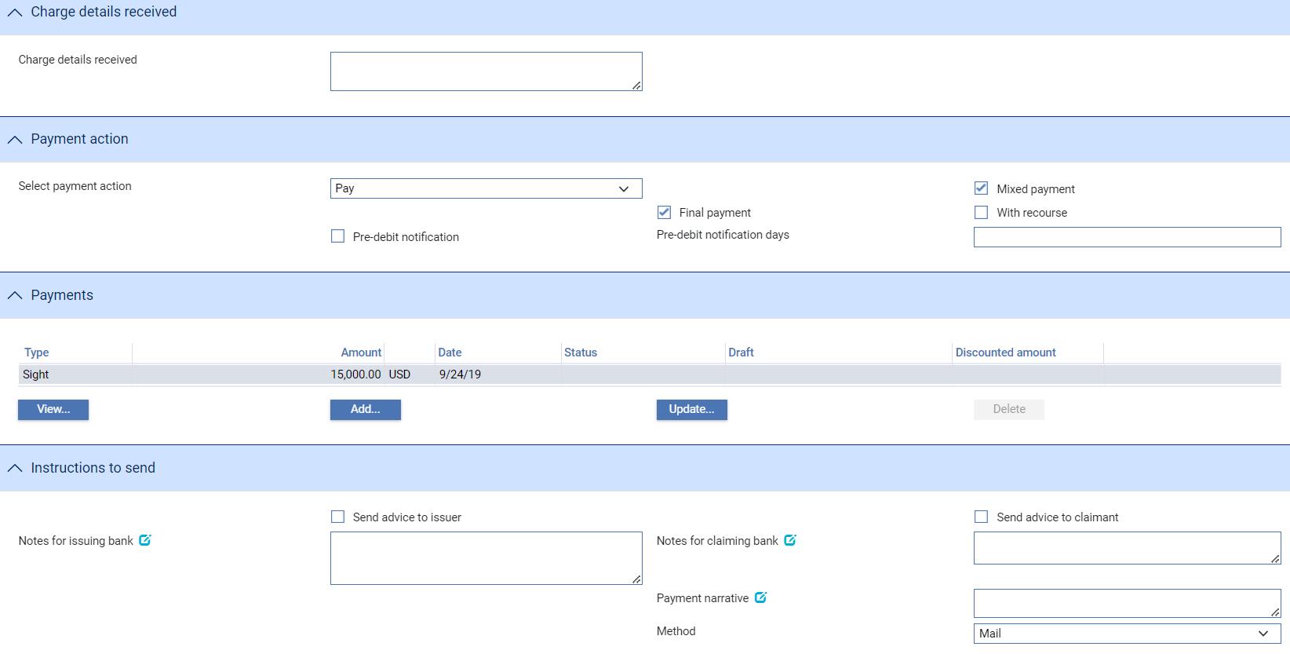

The Input window uses the following panes:

* The Reimbursement Details Pane (see page 17)
* The Claiming Bank Pane (see page 17)
* The Claim Details Received Pane (see page 18)
* The Charge Details Received Pane (see page 19)
* The Payment Action Pane (see page 19)
* The Payment Details Pane (see page 20
* The Associated Payment Details Pane (see page 22)
* The Instructions to Send Pane (see page 22)

### The Reimbursement Details Pane

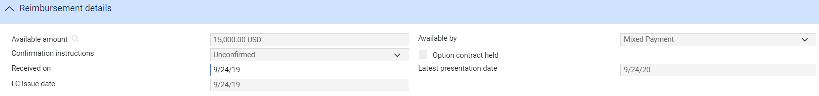

The Reimbursement Details pane allows you to enter details of the reimbursement authority relevant to the claim. The following table explains what to enter into the fields in this pane:

|  |  |
| --- | --- |
| Field | What to Enter |
| Available Amount | The system displays the amount outstanding for the reimbursement authority. |
| Available By | The system displays the reimbursement authority's payment method. |
| Confirmation Instructions | Indicates whether the reimbursement authority has been confirmed or not. |
| Option Contract Held | This field is checked if foreign exchange option contracts are held against the reimbursement authority. |
| Received On | The date on which you received the claim. The system uses today's processing date as the default. |
| Latest Presentation Date | The system displays the latest presentation date for the reimbursement authority. |
| LC Issue Date | The date on when the documentary credit is issued as supplied by Issuing Bank |

### The Claiming Bank Pane

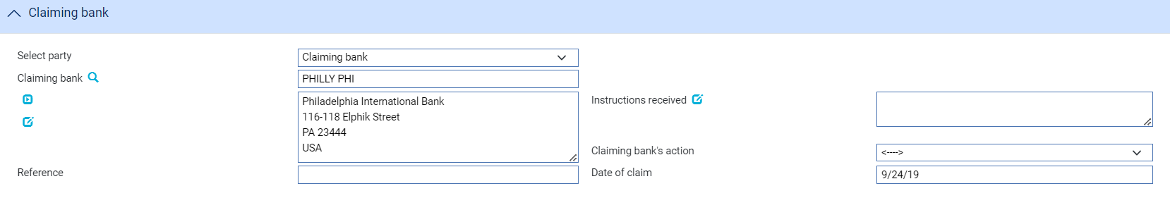

The Claiming Bank pane allows you to enter details of the claiming bank, their instructions and payment action. The following table explains what to enter into the fields in this pane:

|  | Field | What to Enter | |
| --- | --- | --- | --- |
|  | Select Party/Claiming Bank | If a claiming bank has been identified, the system displays its details.  You can select an alternative from the drop-down list: | |
|  |  | Other Claiming Bank | Select the required claiming bank. |
|  |  | Issuing Bank | The system displays the issuing bank's details. |
|  | Reference | The reference for the reimbursement authority, as given by the claiming bank or issuing bank selected in the Clearing Bank pane above. | |
|  | Instructions Received | Any instructions received from the claiming bank. | |
|  | Claiming Bank's Action | Choose one of the following values from the drop-down list to indicate what action the claiming bank has taken with regard to the claim:   * Request Payment * Request Acceptance * Sender has Debited our Account * Other   The Appendix (see page 45) gives more information on claimant's actions. | |
|  | Date of Claim | The date the claiming bank issued the claim. | |

### The Claim Details Received Pane

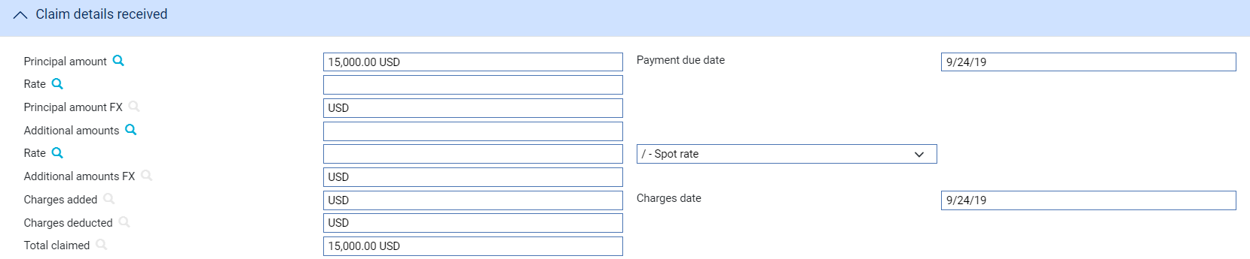

The Claim Details Received pane allows you to enter details of the amount claimed, together with any additional amounts and charges. The following table explains what to enter into the fields in this pane:

|  | Field | What to Enter |
| --- | --- | --- |
|  | Principal Amount | The amount being claimed. While the amount will normally be claimed in the currency of the reimbursement authority, the system permits the amount to be claimed in a different currency. |
|  | Rate | If the amount being claimed is expressed in a currency different from that of the reimbursement authority enter the exchange rate to be used to convert it to the currency of the reimbursement authority. |
|  | Principal Amount FX | The principal amount, expressed in the currency of the reimbursement authority. |
|  | Additional Amounts | Any additional amount being claimed, and the currency in which it is being claimed. |
|  | Rate | If the additional amount is expressed in a currency different from that of the reimbursement authority enter the exchange rate to be used to convert the additional amount to the currency of the reimbursement authority. |
|  | Additional Amount FX | The principal amount, expressed in the currency of the reimbursement authority. |
|  | Charges Added | The total amount of charges (in the currency of the reimbursement authority) added to the principal amount and being claimed by the claiming bank. For complete reconciliation check that this amount is equal to the charges due to the claiming bank - see the Common Facilities User Guide – Trade Innovation for instructions. |
|  | Charges Deducted | The total of your own bank's charges due from the claiming bank and the issuing bank's charges due from the claiming bank which have been deducted from the principal claimed amount. For complete reconciliation check that this amount is equal to the charges due from the claiming bank - see the Common Facilities User Guide – Trade Innovation for instructions. |
|  | Total Claimed | The system calculates the total being claimed and displays the resulting figure here, in the currency of the reimbursement authority. |
|  | Payment Due Date | The date payment is due, or the value date used to debit your account with the claiming bank. |
|  | Charges Date | The value date for any charges taken separately. The system uses today's date as the default. |

### The Charge Details Received Pane



The Charge Details Received pane is present only if the system option MT740/MT742AutoActionTag71B has been set to Yes, and if the event has been created from an incoming SWIFT message. This displays the content of tag 71B of the SWIFT message. Tag 71B will be flagged as ‘Actioned’ in the SWIFT In window, and this field allows you to see its content without opening that window.

### The Payment Action Pane

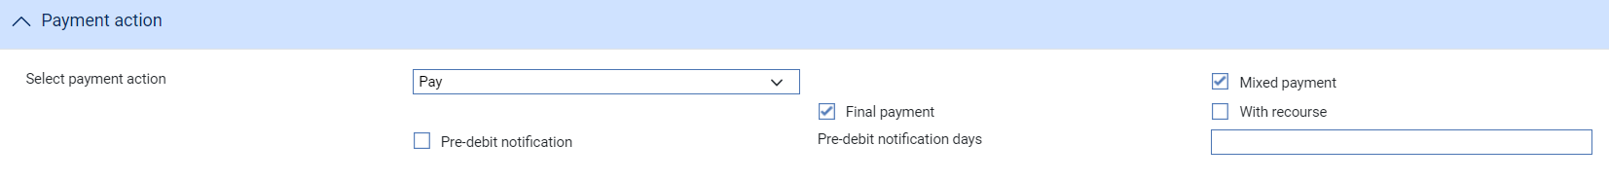

The Payment Action pane allows you to select a payment action and enter related information for processing the claim.

The Select Payment Action field allows you to select the appropriate action for the claim. Actions are of three types:

* Actions that indicate that your bank is paying or will pay the claim in the future
* Rejection, with or without a refund claim
* A request for approval from the issuing bank

For a single payment, details of the actual payment are entered into the Payment Details pane. If payment is mixed, to involve two or more part payments, check the Mixed Payment field, then click **Refresh**. The system displays a Payments pane, which you can use to enter details of each of the part payments in turn.

Check the With Recourse box if the payment is with recourse; and the Final Payment box if the payment includes the final payment under the reimbursement authority.

If your payment action is 'Reject and Claim Refund', click **Refresh** and then enter the date of the refund into the Refund Date field.

The payment action you select applies to all part payments. However, where the action is 'Pay' the individual status of a payment can be changed using the Pay Status field in the Payment Details window.

Note that:

* If you enter any part payment details, the value of all part payments must not exceed the value of the letter of credit, and must reconcile with the claimed amount
* Where the payment action for an individual part payment is 'Pay at Maturity' or 'Accept', the system creates a diary event which will cause an Outstanding Claim or Outstanding Presentation event to be generated automatically at the appropriate time to allow that part payment to be matured
* If the payment action is 'Pay' for an acceptance or deferred payment, the system generates the postings and funds movements for the future date, and no separate future Outstanding Claim or Outstanding Presentation event takes place. The forward-dated postings are held by the system until the value date is reached, then posted during batch processing

If the payment action is 'Request Approval from Issuing Bank', the system displays an additional field - Reasons for Authorisation request - in the Instructions To Send pane.

### The Payment Details Pane

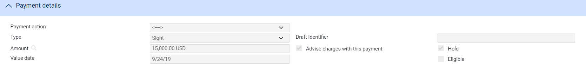

The Payment Details pane allows you to enter details of the payment you are making.

For mixed payment, check the Mixed Payment field in the Payment Action pane. A new pane - the Payments pane - is displayed.

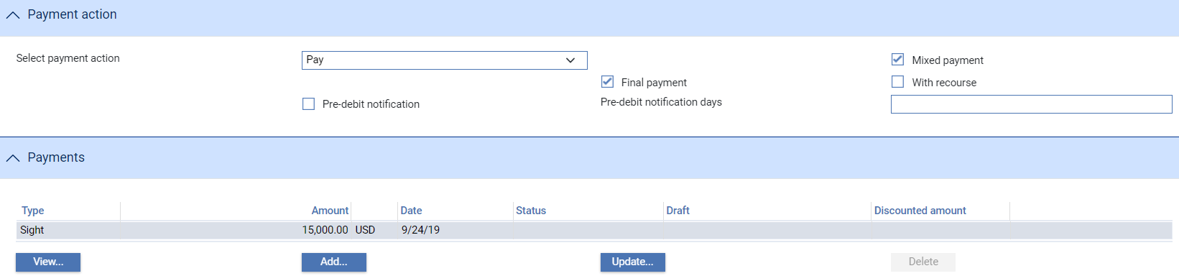

Select the payment listed in this window and click **Update**. In the window that appears, define the first part payment.

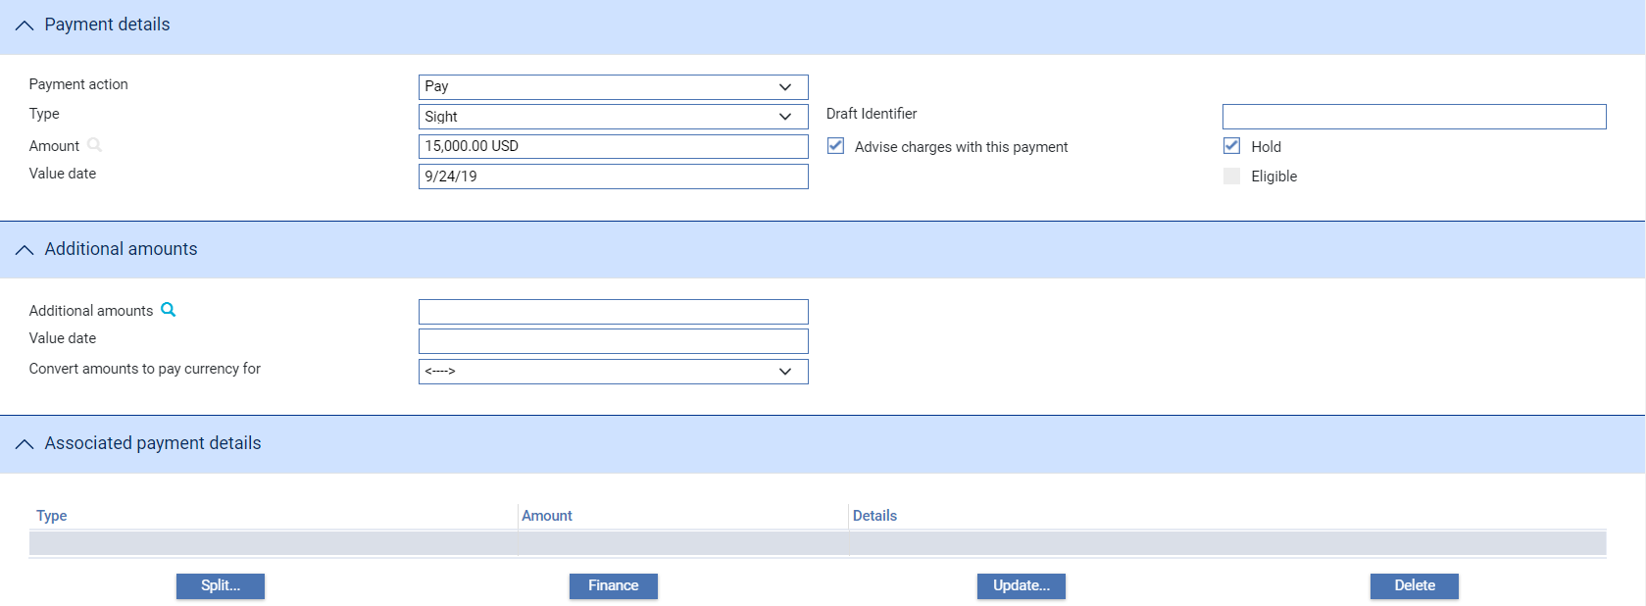

The fields are the same as those used in the Payment Details pane to define a single payment. When you close the window, the details of the part payment are listed in the Payments pane, from where you can select them and amend or delete them. Use the Add button to reopen the window to enter details of the next part payment.

Once you have entered details of a payment, or part payment, it is listed in the Payments pane.

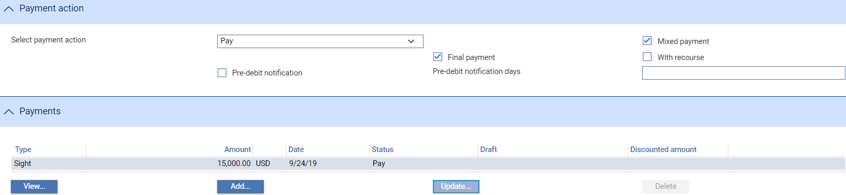

Note that the system creates a first part payment for the full amount of the payment event. If you add more part payments, remember to amend the amount of this first part payment accordingly.

The following table explains what to enter to define a payment or part payment:

| Field | What to Enter |
| --- | --- |
| Payment Action | This field is displayed only for mixed payments, and it initially reflects the payment action selected for the claim in the main Input window. If the payment action involves refusal or leaves the claim outstanding, then you will not be able to alter the value in this field.  If the payment action involves paying the claim, then you can use this field to select a status for each individual part payment.  Select from the available options. |
| Type | Select the type of payment - Sight, Acceptance or Deferred - then click Refresh. The fields displayed in the rest of the window vary, depending on what you enter here. |
| Amount | The amount being claimed. |
| Advise Charge with This Payment | Check this box if charges taken or claimed are to be advised with this payment. |
| Value Date | For sight payments, enter the value date of the payment.  For acceptance and deferred payment the value date of the payment is calculated using the value in the Period field.  The system issues a warning if this date does not leave enough time for any pre-debit notification required. |
| Start Date/Period/From/ After | For acceptance and deferred payments, the start date of the payment period.  Use the Period field to define the period (as, for example, 1 month or 10 days), then use the From/After field to indicate whether the period will be calculated from or after the base date. |
| Draft Identifier | If you know the draft identifier, enter it here. |
| Hold | This field is displayed for sight and acceptance payments. Check it if drafts are being held, and uncheck it if they are being returned to the claimant.  You can discount a draft only if this and the Eligible box are checked. |
| Eligible | This box must be checked for you to be able to discount a part payment. For sight and acceptance payments, the Hold box must also be checked. |
| Additional Amounts | Any additional amount. |
| Value Date | The value date of any additional amount. |
| Convert Amounts to Pay Currency For | The payment amount may need to be converted to a different currency for the paying bank and or the presenting party. If so, select the appropriate value - Presenting Party, Both Parties or Paying Bank - here. |
| Rate to Convert to Payment Currency | If the payment amount needs to be converted to a different currency select or enter the rate to be used to make the conversion. |
| Additional Amounts FX | The additional amount, expressed in the currency of the reimbursement authorisation. |
| Branch | Where relevant, the branch that owns the foreign exchange deal. |

### The Associated Payment Details Pane

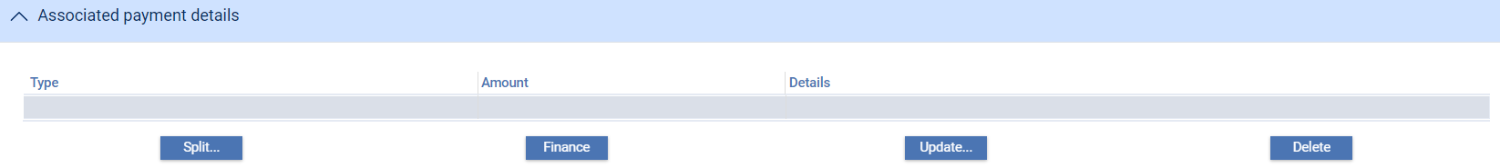

The Associated Payment Details pane allows you to apply further processing against the payment or part payments being made. As payments are defined they are listed in this pane. You can select them individually and enter details of a loan or discount or license drawdown.

Instructions in using this pane are provided later in this chapter (see page 29).

#### The Instructions to Send Pane

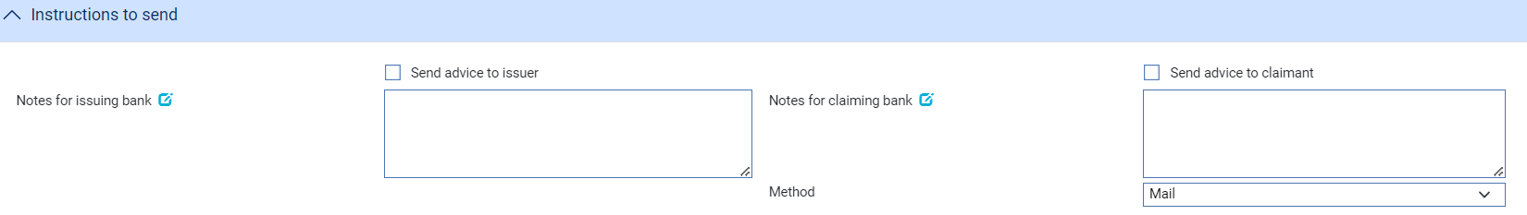

The following table lists the fields in this pane and explains what to enter into the fields in the Instructions to Send pane:

|  |  |
| --- | --- |
| Field | What to Enter |
| Send Advice to Issuer | Check this box if the issuing bank requires to be advised of the claim. |
| Send Advice to Claimant | Check this box if the claimant requires to be advised of the claim. |
| Notes for Issuing Bank | Any notes for the issuing bank. |
| Notes for Claiming Bank | Any notes for the claiming bank. |
| Payment Narrative | Any additional information about advice of reimbursement or payment. |
| Reasons for Authorisation Request | Displayed instead of the Notes for Issuing Bank field if the payment action is 'Request Approval from Issuing Bank'. |
| Method | The method by which advices are to be sent. |

## Completing an Outstanding Claim

If you select 'Request Approval from Issuing Bank' as your payment action during the Claim Received event to postpone completion of a claim while awaiting the issuing bank's approval, the Continue Claim event allows you to open the claim and complete it.

The system will also generate a Continue Claim event automatically the required number of days prior to a claim reaching its value date and you will be able to open the event, either to make changes to it or to discount or finance drafts in the usual way.

To create a Continue Claim event, in the Master Summary window select 'Continue Claim' from the Create New Event drop-down list and click **Create**. The system opens the event at either a Log step or Input step (see page 27), depending on how the Workflow orchestration controlling the event is configured. See the *Workflow Tailoring User Guide* – Trade Innovation for details.

### Selecting the Claim to Continue

If there is only one outstanding claim, the system retrieves it and displays its details. If there is more than one outstanding claim, click **Select** to choose one and the system displays the Select Payment Event window.

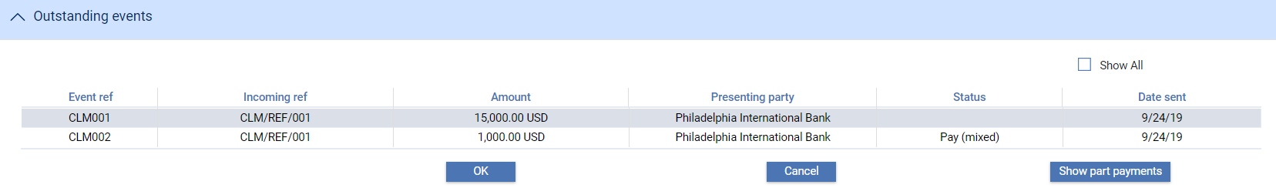  
This window lists all completed Claim Received events that have not been paid. The window does not show any claims currently in progress.

If you check the Show All box, the system also includes in the list all completed Claim Received and Continue Claim events that have been paid in full or been rejected. You can initiate a Continue Claim event against a completed claim event if you need to change the payment action to 'Pay', 'Pay at Maturity' or 'Pay with Financing' or if you need to reject it.

When you select an event and then click **OK**, the system closes the window and displays information taken from that event.

### Logging the Issuing Bank's Response

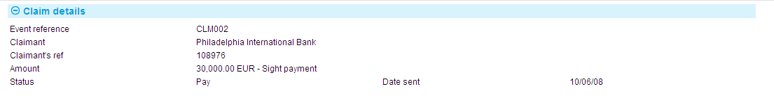

If there is only one outstanding claim, the system retrieves it and displays its details. If there is more than one outstanding claim, use the Select button (see page 26) to select the one to continue.

The table below explains what each of the fields displayed in a Log window shows:

|  |  |
| --- | --- |
| Field | What it Holds |
| Event Ref | The reference of the original Claim Received event that is being continued. |
| Claimant | The claimant. |
| Claimant's Ref | The claimant's reference for the original claim. |
| Amount | The amount of the claim in the original Claim Received event, and the payment type. |
| Status | The status of the claim. |
| Date Sent | The date the original request was sent. |

### Entering Full Details of the Issuing Bank's Response

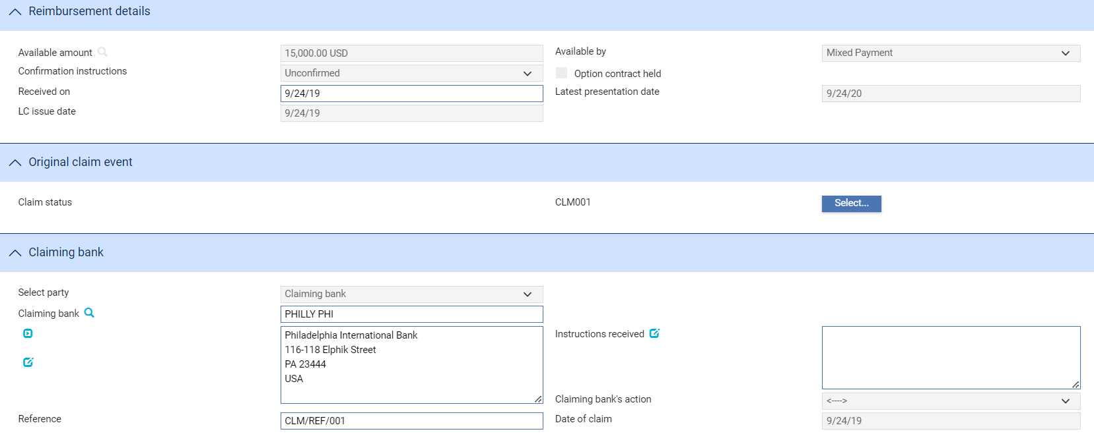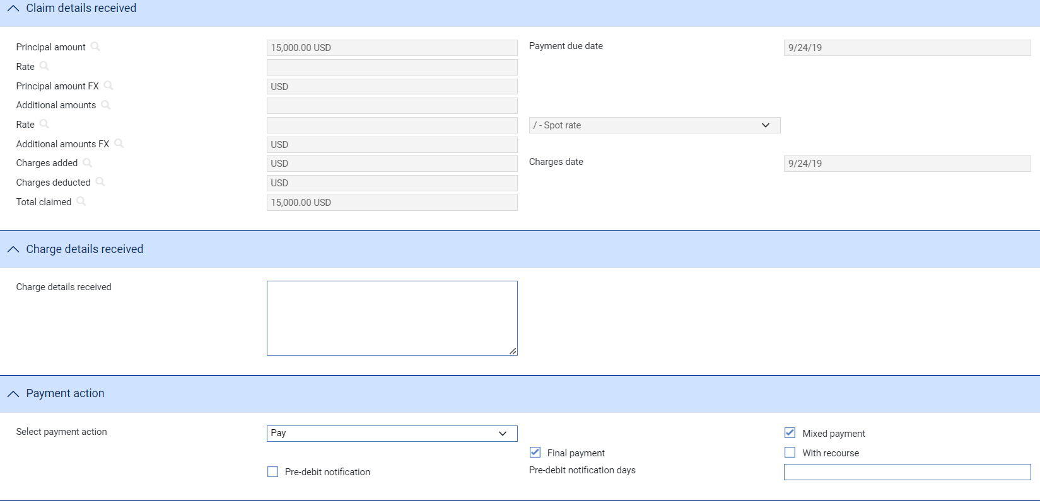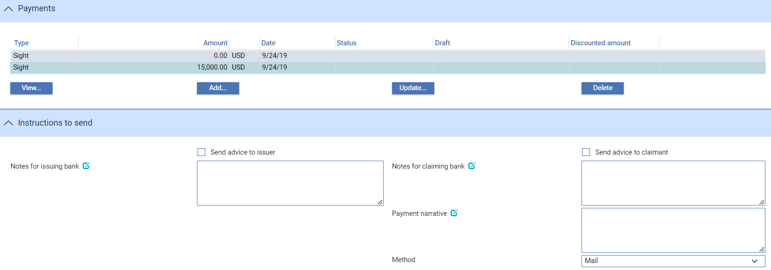

If there is only one outstanding claim, or if a Log step has been used to select the claim where there is more than one outstanding, the system retrieves it and displays the relevant details. Otherwise, use the Select button (see page 26) to select the one to continue.

Use the Received On field to enter the date the response was received.

The Original Claim Event pane displays the reference of the originating Claim Received event, and your bank's payment status in that event.

During a Continue Claim event, you can select from the following payment actions only:

* Pay
* Pay with Financing
* Pay at Maturity
* Reject
* Adjust Maturity (see page 28). Unlike the other payment events, this is available only in a Continue Claim event

With the exception of the Adjust Maturity payment action (see page 28), the payment details are entered in the same way as during a Claim Received event (see page 17).

### Adjust Maturity

The Adjust Maturity payment action enables you to change the value date of a future-dated payment that was specified during the payment event that you are continuing - referred to here as the source event. This may be necessary if, for example, the advising bank requests you to change the date of a future payment.

This action is available only if the AllowAdjustMaturity system option is set on and only in the following circumstances:

* In an Outstanding Claim event or an Outstanding Presentation event
* When the payment action selected in the event that you are continuing was 'Pay'
* The payment date is in the future

Unlike the other payment actions, this action is not available during a Claim Received or Documents Presented event.

You can change the following value dates, provided they are in the future:

* For the payment, in the Value Date field
* For any additional amounts
* For associated charges, using the Settlement Details window (see the Common Facilities User Guide – Trade Innovation)

When you change such a value date the system identifies charges in the source event that were due to be taken on a future value date that has not yet been reached, supersedes them in the source event and includes them in the current event set to 'Take'. Their value date can be changed using the Settlements window.

The system also identifies postings projected in the source event with a value date that has not yet been reached and stops the original projections being posted and generates replacement projections with the revised value date.

Any SWIFT payment messages that have not yet been released are stopped and new messages generated, as appropriate, from the current event. However, If messages from the source event have already been released:

* For funds movement messages (such as MT202), the equivalent messages in the new event are automatically suppressed
* For event document messages (such as MT756), you should set up rules to prevent the issue of such duplicate messages

Any charges or additional amounts that had no value date entered for them will be automatically assigned the new value date for the payment.

Value dates that have passed cannot be changed. For example, if the original claim included part payments and the value date for one of those has now passed, you cannot change the value date for that part payment.

You can enter explanations for or comments on the change in the Notes to Applicant and Notes for Presenter fields.

## Processing Associated Payment Details

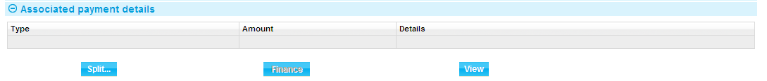

The Associated Payment Details pane allows you to apply further processing against the payment or part payments being made. As payments are defined they are listed in this pane. You can select them individually and enter details of:

* A loan (see page 29) - select the Finance line and click **Update**
* A discount (see page 32) - click **Discount**
* A license - click **Licenses**. See the Licenses User Guide – Trade Innovation for further instructions

### Entering Details of a Loan

1. The functionality described in this section is used to enter loans for systems where Trade Innovation's financing module is not implemented. If your system has the financing module implemented see the Financing User Guide – Trade Innovation for information on processing loans.

For payments where you have selected Pay with Financing or Issue Trust Receipt Loan, a Finance line is included as part of the payment details.

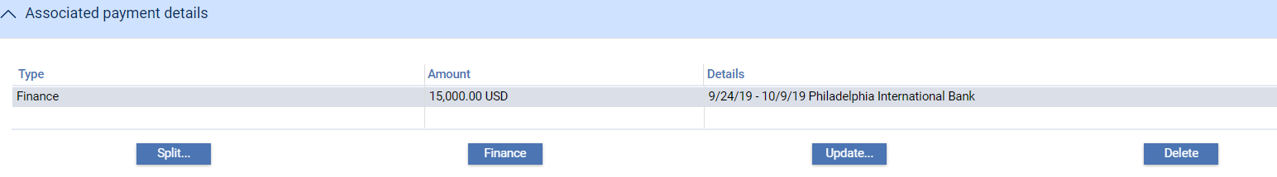

This is used to record information if the applicant to borrow funds in order to defer payment to a later date. Typically, repayment is made from the applicant's own funds at a future date, for example after an onward sale of goods has been arranged. When you double click on this line or select it and click **Update**, the system displays a window which allows you to enter details of a loan being made against a payment.

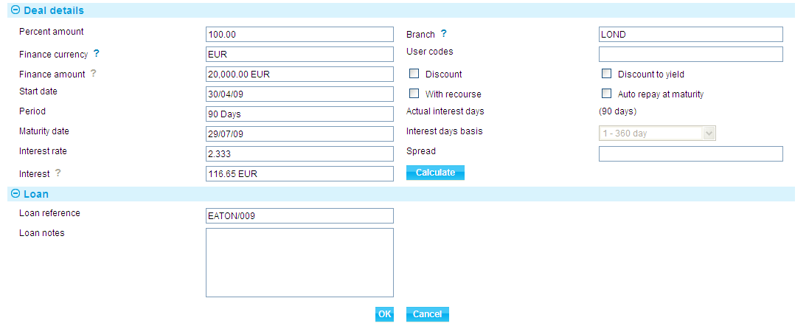

The following table explains what to enter into the field in this window to record details of any such loan.

When you have completed input and closed this window, the Finance line displays the amount and currency of the loan, its start date and maturity date, the interest rate, and the interest/discount amount.

| Field | What to Enter |
| --- | --- |
| Percent Amount | The amount of the part payment to be financed, as a percentage. |
| Discount/ Discount to Yield | Indicate when interest is to be paid. Check the Discount box if interest is to be paid at inception, or leave the box blank if interest is to be paid at maturity.  Check the Discount to Yield box if the discount to yield formula is to be used to calculate the discount instead of the standard discount formula.  If you click on either the Discount box or the Discount to Yield box and click Refresh, the system displays extra fields. |
|  | |
|  | Once you enter a value into the Rate field, click Refresh. The system calculates and displays the discount amount and displays it using the Discount Interest field. Alternatively, you can enter the discount amount into the Discount Interest field, and the system will calculate the interest rate and display it using the Rate field. In either case the system calculates and displays the net amount due using the Net Amount field.  Use the Discount Paid By field to define who will pay the discount interest amount on the loan. The debit party is the applicant and the credit party is the presenter. The system uses the credit party as the default. |
| Finance Currency | The currency of the loan, if different from the currency of the transaction.  If you enter a currency here that is different from the transaction currency, the system displays an Exchange Rate field for you to identify the exchange rate to be used to convert the loan amount from the transaction currency.  When you have selected an exchange rate click Refresh. The system calculates and displays the converted amount in the Finance Amount field. |
| With Recourse | Use this field to indicate whether or not the loan is with recourse. By default, the box is unchecked and the loan is without recourse. |
| Start Date | The start date of the loan. The system uses the part payment value date as the default. |
| Period/ Maturity Date | The maturity date for the loan. Either enter the maturity date; or use the Period fields to identify the number of days, weeks, months, quarters or years after its start date the loan will mature. If you select the latter option, the system calculates the maturity date and displays it in the Maturity Date field.  The Maturity Date field may be left open for loans with interest payable at maturity. This allows the maturity date to be entered as the loan is repaid. |
| Rate | The overall rate at which interest or discount is to be will be required to record details of the repayment manually.  This field can be checked only if the Maturity Date field is not blank. |
| Spread | The spread rate that has been added to the interest rate. This is used for reporting purposes only. Your bank will have devised its own system for using this field.  The values entered here will appear on the deal generated for the loan. |
| Branch | The branch that owns the loan. |
| Discount Paid By | Select which party is to pay the discount - the credit party or the debit party. |
| Discount Interest | The discount interest amount. |
| Net Amount | The amount to be advanced. The system uses the amount claimed as the default here, and converts it using information entered in the previous fields. |

### Discounting Payments

The functionality described in this section is available only if you do not have Trade Innovation's financing module implemented.

For payments where you have checked both the Eligible box and the Hold box, the Discount button in the Associated Payment Details pane is enabled.



This allows you to record details of a payment to be made to the presenter before the date due under the terms of the master record.

When you click **Discount,** the system opens a window for you to enter details of the discount.

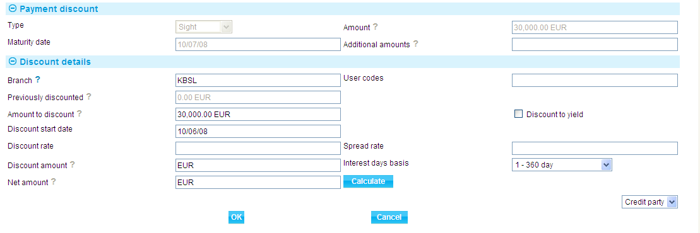

Details of the payment or part payment being discounted are displayed at the top of the window. The table below explains what to enter into the field in this window. Pressing **Calculate** updates the fields, using the values you have entered.

|  | Field | What to Enter |
| --- | --- | --- |
|  | Previously Discounted | If a discount has already been given against the transaction, the amount against which the discount was given. |
|  | Amount to Discount | The amount of the discounted payment for which the early payment is to be made. This may be up to the amount due under the part payment, including additional amounts. |
|  | Discount Date | The date the discounted payment is to be made. The system uses today's date as a default. |
|  | Spread Rate | The spread rate that has been added to the interest rate. This is used for reporting purposes only. |
|  | Days Basis | The days basis to be used to calculate the interest. A list of valid values is given in the Common Facilities User Guide – Trade Innovation. |
|  | Discount to Yield | Click once on the Discount to Yield box so that it is checked if the discount to yield formula is to be used to calculate the discount instead of the standard discount formula. |
|  | Discount Amount | The amount of the discount. If you enter the interest rate into the Discount Rate field, the system calculates the discount and displays it in this field, where you can overwrite it. Alternatively, you can enter the discount value directly into this field and the rate will be automatically recalculated. |
|  | Discount Rate | The interest rate to be used to calculate the discount interest amount. Enter the overall rate at which discount is to be calculated (including the spread).  Alternatively, you can enter the discount as an amount in the Discount Amount field. |
|  | Net Amount | The total value of the early payment, taking into account any discount due. |
|  | Discount Paid By | Indicate which party is to pay the discount on the early payment. |
|  | User Codes | You may use this field to enter a value for analysis purposes. Your bank will have devised its own system for using this field.  The values entered here will appear on the deal generated for the loan. |
|  | Branch | The branch that owns the discount deal. |

# Repaying a Loan

1. The functionality described in this chapter is used to repay loans for systems where Trade Innovation's financing module is not implemented. It is also used to repay loans entered on your system prior to the implementation of financing. If your system has the financing module implemented see the Financing User Guide – Trade Innovation for information on repaying loans against reimbursement authorities.

Loans can be repaid in part or in full using the Loan Repayment event.

In the Master Summary window select 'Loan Repayment' from the Create New Event drop-down list and click **Create**. The system opens the event at either a Log step (see page 34) or Input step (see page 35), depending on how the Workflow orchestration controlling the event is configured. See the *Workflow Tailoring User Guide* – Trade Innovation for details.

## Selecting the Loan to Repay

When you open the Loan Repayment event, if there is only one loan associated with the reimbursement authority, the system retrieves it and displays its details. If there is more than one loan, click **Select** to choose the loan you want to complete and the system lists all the loans against the reimbursement authority awaiting repayment.

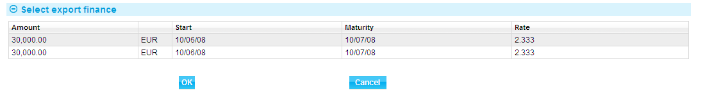

Highlight the loan that is to be repaid, then click **OK**. The system retrieves details of that loan and displays them.

## Logging the Loan Repayment

When you open the Loan Repayment event, if there is only one loan associated with the reimbursement, the system retrieves it and displays its details.

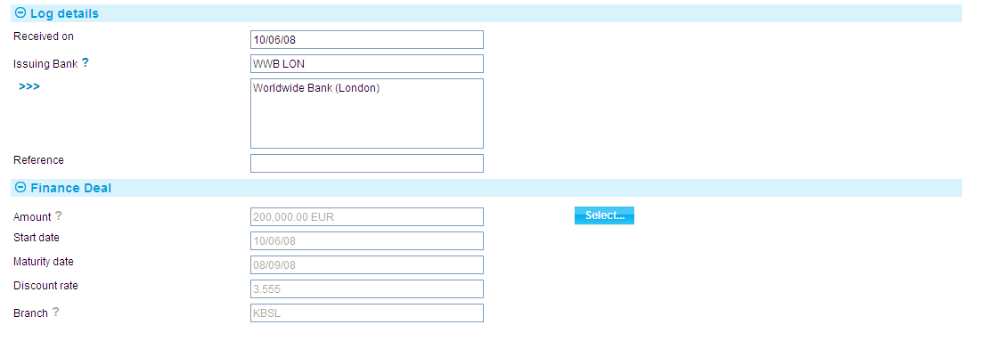

If there is more than one loan, you can use the Select button (see page 34) to select the one you which to complete.

The following table explains what to enter into the fields used to log a loan repayment:

|  |  |
| --- | --- |
| Field | What it Shows |
| Received On | The date on which you received the repayment. The system uses today's date as the default. |
| Issuing Bank | The issuing bank's details are displayed. |
| Reference | The issuer's reference for the loan repayment. |
| Amount | The amount of the payment or part payment against which the loan was made. |
| Start Date | The start date of the loan is displayed. |
| Maturity Date | The date on which the loan is due to be repaid in full is displayed. |
| Discount Rate | The discount rate is displayed. |
| Branch | The branch that owns the loan. |

### Entering Full Details of the Repayment

When you open the Loan Repayment event, if there is only one loan associated with the reimbursement, the system retrieves it and displays its details. If there is more than one loan, you can use the Select button (see page 34) to select the one you which to complete.

During the Loan Repayment event's Input step, the system uses one of two windows, depending on the type of loan.

One window is used if the loan has interest paid at inception.

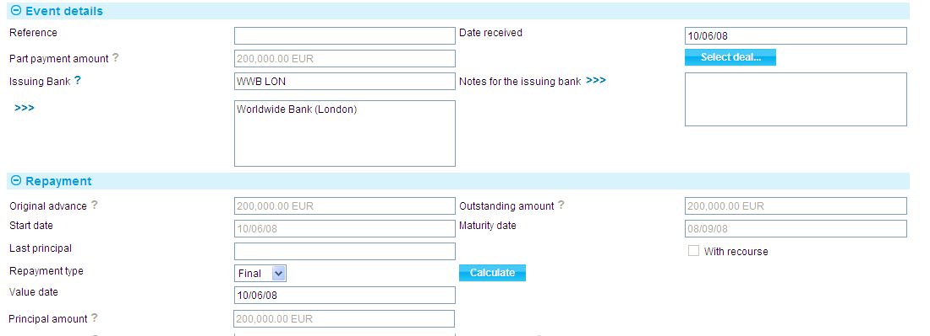

Another window is used if interest on the loan is due at maturity.

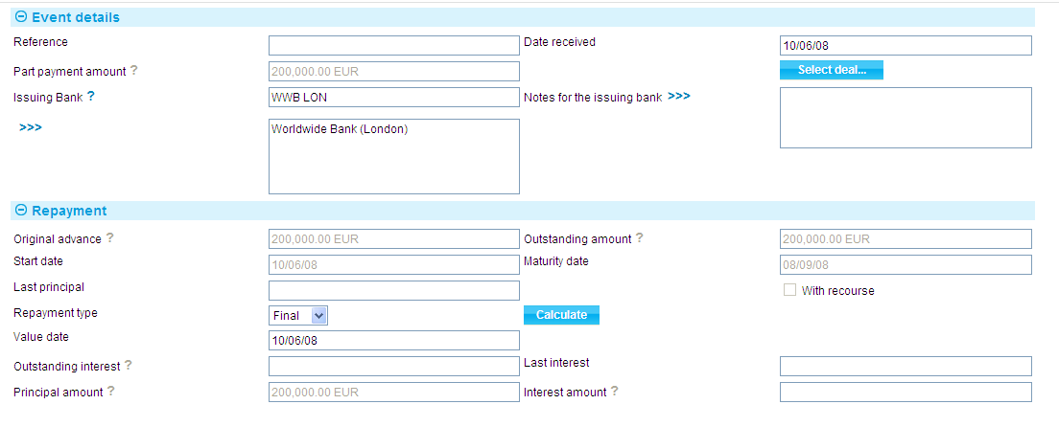

The following table explains what to enter into the fields in this window. You can use them to repay the loan in full (see page 37) or in part (see page 37):

|  |  |
| --- | --- |
| Field | What to Enter |
| Reference | The issuer's reference for the loan repayment. |
| Date Received | The date on which you received the repayment. The system uses today's date as the default. |
| Part Payment Amount | The amount of the part payment against which the loan was made. |
| Issuing Bank | Displays the issuing bank's details. |
| Notes for Issuing Bank | Enter any notes for the issuing bank regarding the repayment. |
| Original Advance | Displays the amount and currency of the original loan, excluding any repayments that may have been made. |
| Outstanding Amount | Displays the amount of the loan still outstanding, and the code of the currency of the amount. This is the original amount minus any principal repayments that have been made. |
| Start Date | Displays the start date of the loan. |
| Maturity Date | Displays the date on which the loan is due to be repaid in full. |
| With Recourse | Displays whether the original advance was with recourse or not. |
| Discount | For a discounted loan, this box is checked to indicate that interest on the loan was paid at inception. |
| Discount to Yield | For a discounted loan, this box is checked if the discount to yield formula was used to calculate the discount instead of the standard discount formula. |
| Outstanding Interest | For non-discount loans, this field shows any outstanding interest. If the repayment is against a discounted loan, then the system will not display the interest amount field as interest will have been taken at inception. |
| Last Interest | For non-discount loans, this field shows the value date of the most recent payment of interest against the loan. |
| Last Principal | Displays the value date of the most recent repayment of principal against the loan. |
| Repayment | Indicate whether the repayment is a partial payment or a final repayment of the balance of the loan. |
| Value Date | The date on which the repayment is to be made. The value date cannot be before the last processing date if interest is being paid. If principal only is being paid, the value date cannot be before the last interest payment date. |
| Principal Amount | Displays the amount of the loan outstanding, with the code of its currency. If you use the Repayment field to indicate that this is the final payment against the loan, then you cannot alter the amount shown here. However, if you use the repayment field to indicate that this is a partial payment, then you can enter the amount of the loan being repaid into this field. |
| Interest Amount | If you have used the Repayment field to indicate that this is a final payment, the system displays the balance of the interest still outstanding in this field, and you will not be able to alter it. If, however, you have used the Repayment field to indicate that this is a partial repayment, then enter the amount of interest being paid with this part payment, together with the relevant currency code. |

#### Repaying the Loan in Full

To repay the loan in full, select 'Final' in the Repayment Type field. The system displays the full amount of the loan outstanding in the Principal Amount field, and for non-discount loans the full amount of any interest due in the Interest Amount field. You cannot overtype these figures. The system repays the outstanding amount using the value date entered for the loan repayment.

#### Making Partial Repayments

To enter a partial repayment, select 'Partial' in the Repayment Type field, then enter the amount of the principal being repaid in the Principal Amount field and for non-discount loans any interest being repaid in the Interest Amount field. The balance of the loan will be reduced by the amount entered for the value date, and interest will be posted for the loan for the value date entered.

# Amending or Stopping a Reimbursement Authority

The Amend event permits you to amend or stop (see page 1) a reimbursement authority at any time between the release of the Receive Authority event that created it and expiry.

Once a reimbursement authority is stopped, the system will prevent you from initiating a new payment event, or from completing an existing one. If you need to stop a reimbursement authority while there is a payment event in progress, you can abort the payment event, if necessary.

Your bank can use Trade Innovation’s reversal posting facilities to set up the necessary reversal postings to handle amendments which may have an effect on any previous liability accounting, such as changes to confirmation instructions or the tenor of a payment.

## Amending a Reimbursement Authority

To amend a reimbursement authority, in the Master Summary window select 'Amend' from the Create New Event drop-down list and click **Create**. The system opens the event at either a Log step or Input step. Depending on how your system is configured, panes and fields available in log steps can be tailored for each data capture step. See the *SDK - Screen Tailoring Guide* – Trade Innovation for details.

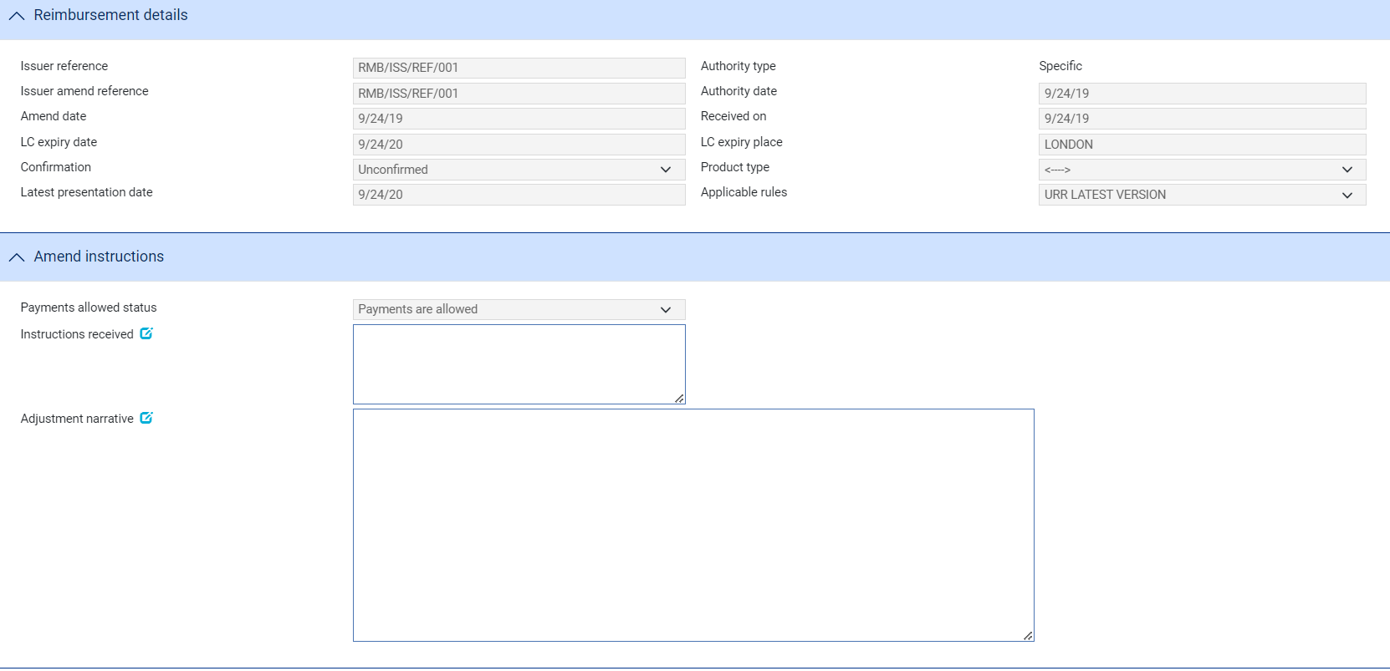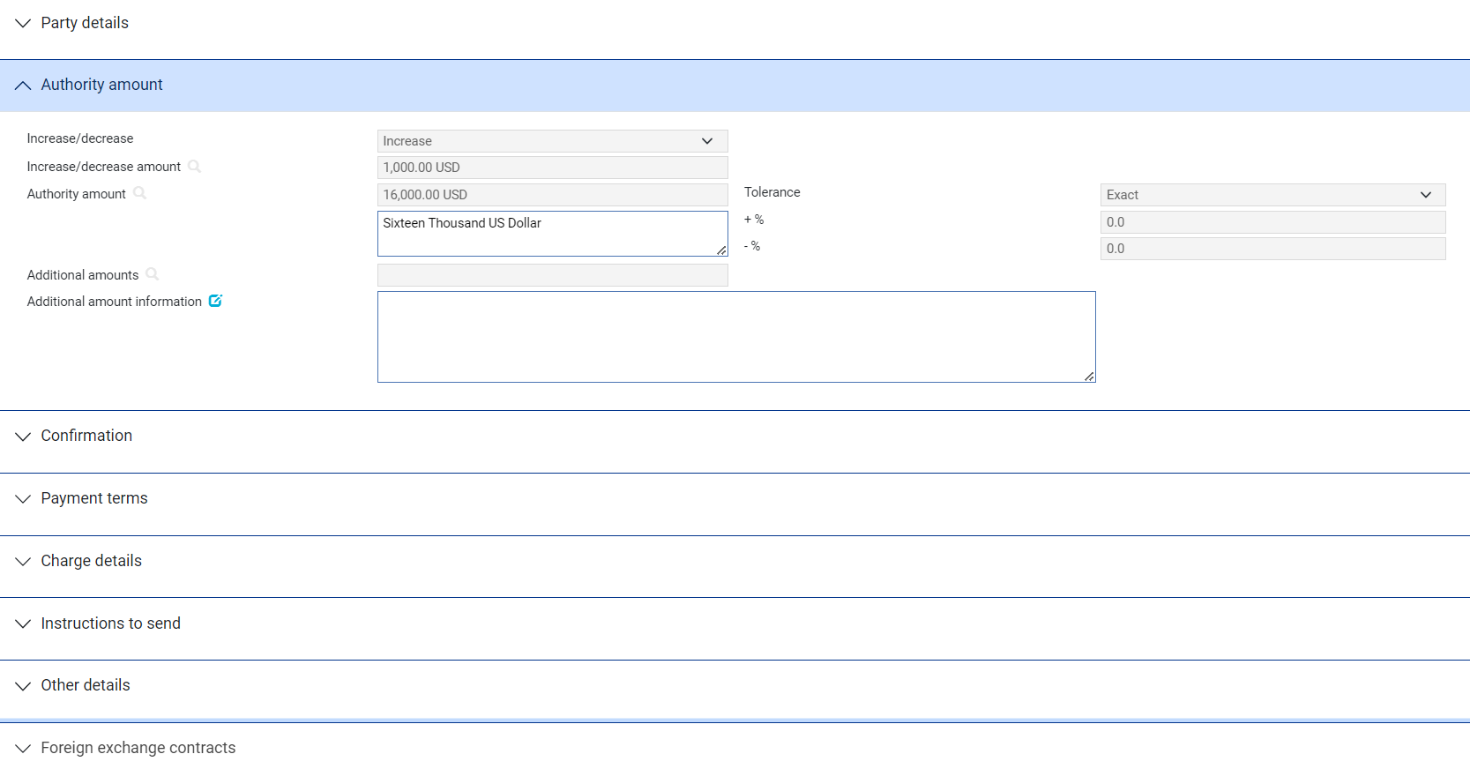

The fields enabled for input are a sub-set of those used when the transaction was created. As you make changes, the Changes button allows you to see what changes you have made (see page 39), showing the original and the new values for amended fields.

The following additional fields are present to allow you to enter details relating to the amendment:

| Field | What to Enter |
| --- | --- |
| Issuer Amend Reference | The issuing bank's reference for the amendment. |
| Amend Date | The date of the amendment. |
| Payments Allowed Status | Used to stop a reimbursement authority or to reactivate a stopped reimbursement authority to allow payments.  To stop the reimbursement authority select 'Stop Payments'.  You can reactivate a stopped reimbursement authority to allow payments to be processed against it by selecting 'Payments are Allowed'. |
| Instructions Received | Any instructions received regarding the amendment. |
| Adjust/Amend Narrative | Information on, for example, the changes made or the reason for the amendment. |
| Increase/Decrease  Increase/Decrease Amount | You can amend the reimbursement authority amount by overtyping the existing amount shown in the Authority Amount field.  Alternatively use these fields to apply an increase or decrease. Use the Increase/Decrease field to indicate whether the amendment involves an increase or a decrease, then enter the amount involved in the increase/Decrease Amount field. When you click Refresh, the increase/decrease is applied to the original reimbursement authority amount and the display updated. |

## Making Adjustments to the Master Record

The functionality of the Amend event allows you to make all the changes that are likely to be required in the normal course of business at the request of the issuing bank.

The system also includes an Adjust event, which provides additional functionality to allow you to make changes to all the information recorded for a reimbursement authority.

Once you have initiated an Adjust event, the system will prevent you from opening any other event for the reimbursement authority until the Adjust event has completed. If you attempt to open an Adjust event while another event for the master is in progress, the system will warn you of the fact and prompt you to abort the Adjust event. Unless you are attempting to make an adjustment to allow the pre-existing event to complete, you should abort the Adjust event and wait until the pre-existing event has completed before attempting the Adjust event again. If you continue with the Adjust event, then the system will prevent any further work on the pre-existing event until the Adjust event has completed.

Note that, if you complete an Adjust event while there is another event in progress (that is, an event pended at an Input step, or awaiting review or authorisation), then when you open that event to continue work on it, the system produces a warning advising you that the database may have changed since the event was initiated and identifying the Adjust event responsible. This allows you to view the Adjust event and identify what has changed.

1. This functionally is intended to allow you to correct mistakes, and should be used cautiously. If you make any changes using this functionality, you should ensure that the proper reconciliations are carried out.

### Making an Adjustment

To adjust a reimbursement authority, in the Master Summary window select 'Adjust' from the Create New Event drop-down list and click **Create**. The system opens the event at either a Log step or Input step, depending on how the Workflow orchestration controlling the event is configured. See the *Workflow Tailoring User Guide* – Trade Innovation for details.

Depending on how your system is configured, panes and fields available in log steps can be tailored for each data capture step. See the *SDK - Screen Tailoring Guide* – Trade Innovation for details.

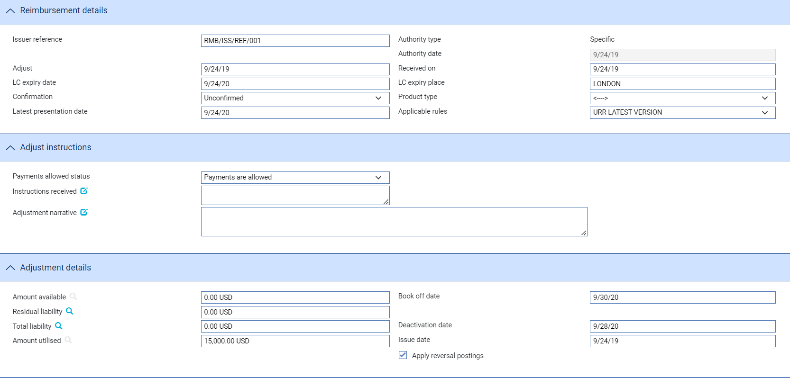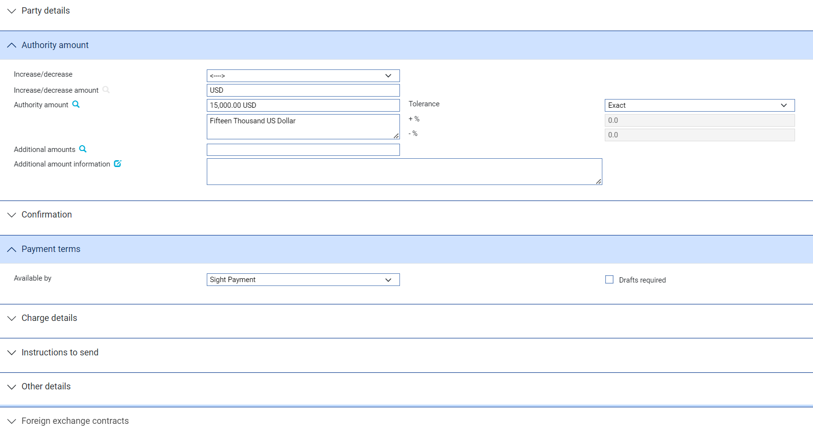

The panes used allow you to amend the details of the reimbursement authority already entered.

1. You can view charges and add optional charges, but cannot edit existing charges. To change charges, use a Maintain Charges event.

As you make changes, the Changes button (see page 42) allows you to see what changes you have made, showing the original and the new values for amended fields.

The following additional fields are present:

| Field | What to Enter |
| --- | --- |
| Adjust | The date of the adjustment. |
| Payments Allowed Status | Used to stop a reimbursement authority or to reactivate a stopped reimbursement authority to allow payments.  To stop the reimbursement authority select 'Stop Payments'.  You can reactivate a stopped reimbursement authority to allow payments to be processed against it by selecting 'Payments are Allowed'. |
| Adjustment Narrative | Information on, for example, the changes made or the reason for the adjustment. |
| Amount Available | The available amount of the reimbursement authority. |
| Residual Liability | The system displays the outstanding liability amount as shown on the master record, excluding the amounts of any presentations. Use this field to overwrite the figure shown on the master summary if, for any reason, the master figure is incorrect. |
| Total Liability | The system displays the outstanding liability amount as shown on the master record, including that of accepted drafts not yet paid. Use this field to overwrite the figure shown on the master summary if, for any reason, the master figure is incorrect. |
| Book Off Date | The system displays the reimbursement authority's book-off date, which you can amend. The system will then book off the reimbursement authority when the new book-off date is reached. |
| Deactivation Date | The system displays the date on which the reimbursement authority will become inactive (after its expiry date and any days grace period has elapsed). You can amend this date. |
| Issue Date | The reimbursement authority's issue date. |
| Amount Utilised | The amount of the reimbursement authority utilised so far. |
| Apply Reversal Postings | This field is only displayed if the DoNotApplyReversalPostings system option is set to No. Leave it checked if your bank has set up reversal postings for the reimbursement Adjust event and wishes to apply them when the event is released. |
| Increase/Decrease  Increase/Decrease Amount | You can amend the reimbursement authority amount by overtyping the existing amount shown in the Authority Amount field.  Alternatively use these fields to apply an increase or decrease. Use the Increase/Decrease field to indicate whether the amendment involves an increase or a decrease, then enter the amount involved in the Increase/Decrease Amount field. When you click Refresh, the increase/decrease is applied to the original reimbursement authority amount and the display updated. |

### Displaying Changes

During Adjust and Amend events, the Changes button lists those fields that have been changed, showing for each field that has changed the value before the Amend/Adjust event began and the new value. This button also allows reviewers to identify what has changed and how.

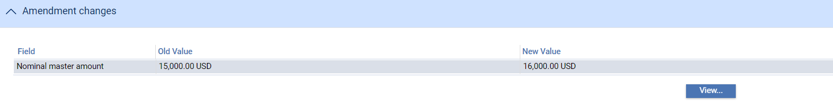

For free-format narrative fields, your bank can configure Trade Innovation so that it shows either the entire content of the field in the New Value column, or just a certain number of lines (defined by the system option ViewChangesLineCount) followed by the text:

>>> plus n more lines. 'View' for details.

where n is the number of additional lines not displayed.

Selecting that entry in the list and pressing **View** displays the entire content of the field.

If you work with this window open, use the Refresh button to update the display to show any changes made since you opened the window.

# Cancelling a Reimbursement Authority

A reimbursement authority can be cancelled using a Cancel Authority event at any time after the release of the Receive Authority event and book-off, provided that there is no work in progress on the reimbursement authority. Typically, cancellation will be initiated by the issuing bank at the request of the applicant.

A Cancel Authority event can be created automatically by an incoming SWIFT MT747 or MT799 message.

As soon as the Cancel Authority event has been released, accounting entries are produced to reduce the liability and liability outstanding to nil and the master record is given the status CAN, although it is not removed from the system.

1. Cancelled reimbursement authorities can be reinstated using an Amend event (see page 38).

A reimbursement authority can also be cancelled from within a letter of credit, either from within a payment event or using a Cancel Reimbursement event. See the Import Letters of Credit User Guide – Trade Innovation.

## Cancelling a Reimbursement Authority

To amend a reimbursement authority, in the Master Summary window select 'Cancel Authority' from the Create New Event drop-down list and click **Create**. The system opens the event at either a Log step or Input step, depending on how the Workflow orchestration controlling the event is configured. See the *Workflow Tailoring User Guide* – Trade Innovation for details.

Depending on how your system is configured, panes and fields available in log steps can be tailored for each data capture step. See the *SDK - Screen Tailoring Guide* – Trade Innovation for details.

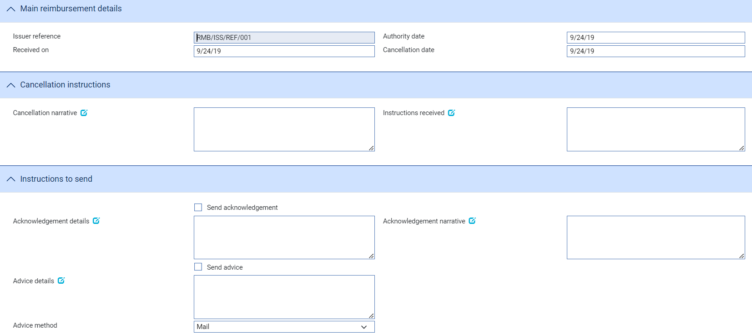

The following table explains what to enter into the fields displayed to cancel the reimbursement authority:

| Field | What to Enter |
| --- | --- |
| Issuer Reference | The issuing bank's reference for the reimbursement authority. |
| Received On | The date the instruction to cancel the reimbursement authority was received. The system uses today's processing date as the default. |
| Authority Date | The date the reimbursement authority was entered on your system. |
| Cancellation Date | The date the cancellation is to take effect. The system uses today's processing date as the default. |
| Cancellation Narrative | Any narrative received with the cancellation. |
| Instructions Received | Any instructions received with the cancellation. |
| Send Acknowledgement | Check this field if the issuing bank requires the reimbursement authority to be acknowledged. |
| Acknowledgement Details | Any free format text, for example charge details, to be included on the acknowledgement to the issuing bank. |
| Send Advice | Check this box is an advice of cancellation is required by the issuing bank. |
| Advice Details | Any free format text for inclusion on the advice to the claiming bank. |
| Advice Method | The method by which the advice is to be transmitted. |

# Appendix Payment Actions and Charges

This appendix explains how Trade Innovation handles the processing of charges during a payment event for reimbursements.

This appendix covers only the special processing for reimbursements. For a full account of how Trade Innovation handles charges see the Common Facilities User Guide – Trade Innovation.

## Claimant's Actions

The following table lists all the claimant's actions supported by Trade Innovation and explains when they might be used:

|  |  |
| --- | --- |
| Presenter's Action | What it Signifies |
| Request Payment | The claiming bank is requesting payment. |
| Request Acceptance | The claimant is requesting payment and or acceptance of drafts. |
| Sender has Debited our Account | The claimant has paid the beneficiary and has debited the receiver's account. |
| Other | Used when the payment action involves more complex instructions, for example where discounting of acceptances is being requested. The Notes fields should be used to provide details. |

1. In addition to the standard Trade Innovation actions mentioned above, your bank may define other actions (which are based upon the standard actions) in order to satisfy your internal processes. These additional actions will also be available in the drop-down list.

See the *System Tailoring Guide* – Trade Innovation for instructions on defining additional payment actions.

## Charges

When requesting authority to make payment against a reimbursement authority, it is sometimes necessary for the bank to defer charges until a later date. Trade Innovation handles this by allowing you to edit charges in order to defer or waive them when they are set to 'Take'.

The table indicates the effect of different payment actions behaviours on charges for reimbursements. In each case, the effect is the same for all types of charge:

* Our charges for buyer
* Our charges for seller
* Other party charges
* Other bank's charges for buyer
* Other bank's charges for seller

## Charges Table

|  |  |  |  |
| --- | --- | --- | --- |
| Payment Action Behaviour | Payment Status | What it Does | Charge Action |
| Accept | Accept | The payment will be made at maturity. The acceptance advices such as MT799 can be produced immediately and the payment will be automatically processed by the diary when the maturity falls due so that it can be continued and paid and the relevant SWIFT messages generated.  This is available for acceptance payments only. | Take |
| Pay | Paid | The claim is to be paid and postings generated. The payment advices such as MT756 can be produced immediately. If the payment is a mixed payment each part payment is initially set to have a status of 'Pay' which can be overridden as required to one of the following pay statuses:   * Pay * Pay at maturity * Accept (if acceptance part payment only) | Take |
| Pay at Maturity | Pay/Maturity | The payment will be made at maturity. The payment advices such as MT756 can be produced immediately and the payment will be automatically processed by the diary when the maturity falls due so that it can be continued and paid. | Take |
| Pay with Financing | Paid | This allows the finance button to be made available allowing details of a deal to be entered to fund the receipt of funds from the issuer. | Take |
| Reject |  | The claim is refused, and the claimant and the issuer can be informed accordingly using MT799s or equivalent. No payment is made. This is typically used to generate an MT799. | Take |
| Reject and Claim Refund |  | The claim is refused, and the claimant and the issuer can be informed accordingly using MT799s or equivalent. The value date allows the date of refund to be specified where the sender has already debited the receiver's account. This is typically used to generate an MT799. | Take |
| Request Approval from Issuing Bank | Outstanding | Your bank does not pay but seeks authorisation to pay from the applicant. | Take |